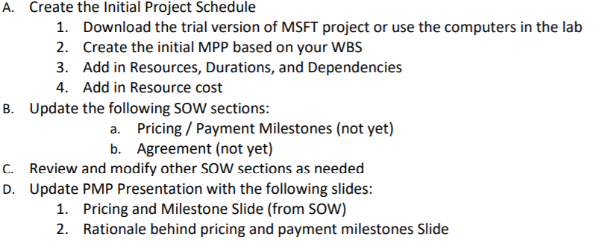

3 deliverables - Project schedule, Statement of Work, Project Management Plan.

Delegation of student responsibilities-

Meeting on Sunday @3pm

Requirements

Design

Development

Testing

Deployment

Launch